NAME: SHIVATHMIKA V
REGNO:192521028
SUBJECT: COMPUTER ARCHITECTURE CSA1204
Q1. Smartphone Performance Optimization
Problem
A smartphone manufacturer observes lag while switching between applications. The main reason can be inefficient memory access and insufficient cache utilization. The system uses L1, L2, L3 cache and DRAM, each having different latency and capacity characteristics.
Analysis
- L1 Cache: Smallest and fastest cache. It stores frequently used instructions and data.
- L2 Cache: Larger than L1 but slightly slower. It acts as an intermediate cache.
- L3 Cache: Larger and slower than L1 and L2. It can be shared among processor cores.
- DRAM: Provides large-capacity main memory but has much higher access latency than cache.
When switching between applications, frequently accessed data should remain in cache. If the required data is not available in the cache, the processor must access DRAM, increasing latency.

Proposed Memory Hierarchy
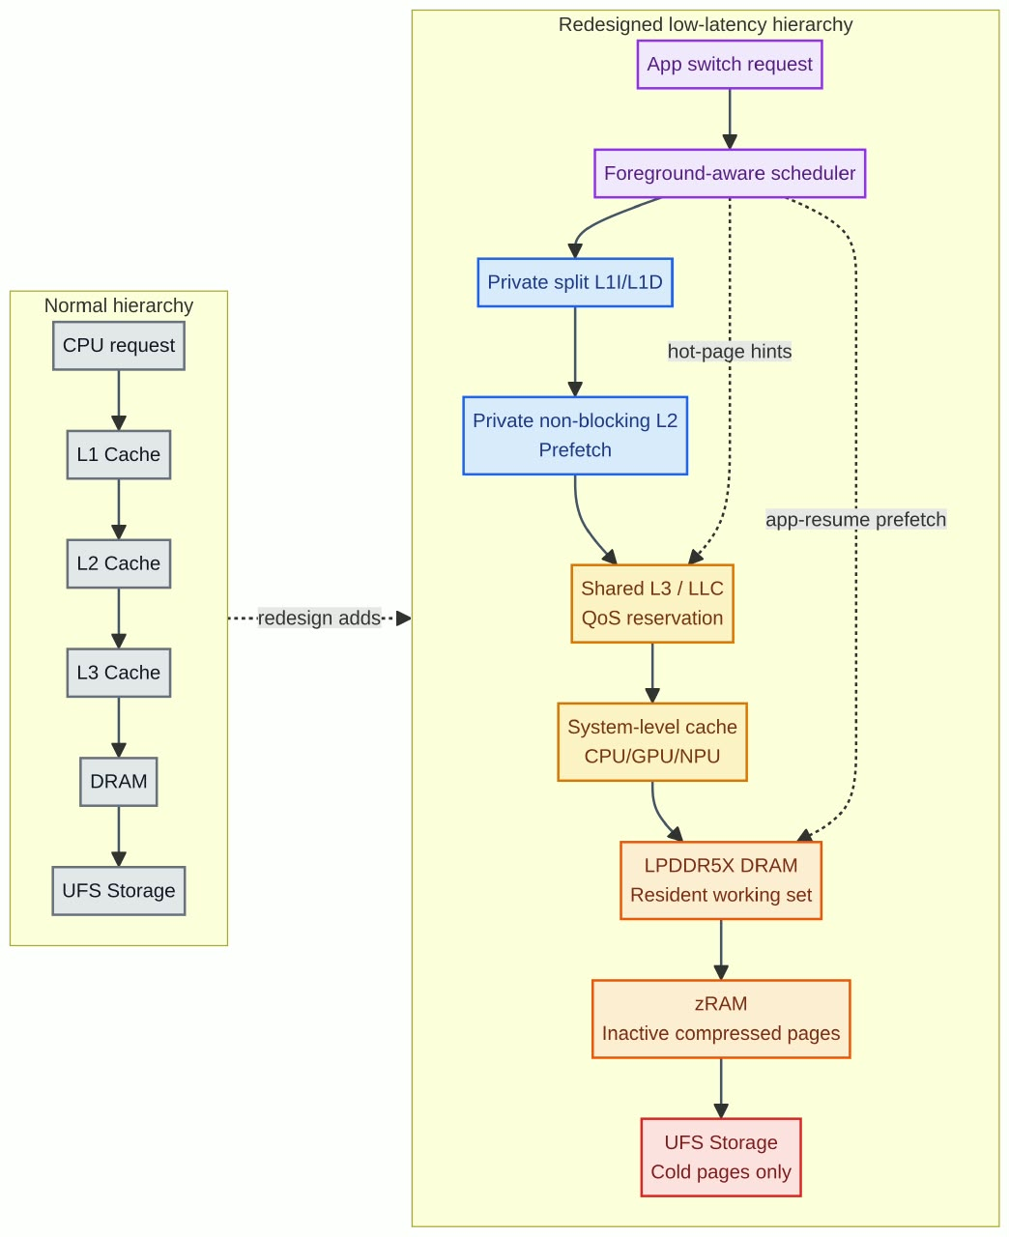
Proposed Improvements
- Increase effective L2/L3 cache capacity.
- Improve cache hit rate using better replacement policies.
- Keep frequently accessed application data in cache.
- Use high-speed DRAM with sufficient bandwidth.
- Optimize memory management to reduce unnecessary DRAM accesses.
Expected Result
The redesigned hierarchy reduces average memory access latency and improves application switching performance. Frequently used data is served from faster cache levels, while DRAM is used mainly for larger data requirements.
Q2. Cloud Server Memory Bottleneck
Problem
A cloud service provider experiences high latency during database queries. The solution requires comparing cache hierarchy and virtual memory paging and selecting appropriate memory technologies.
Analysis
Database queries frequently access the same instructions and data. Cache memory can store frequently accessed database information close to the processor.
Virtual memory uses paging to provide a larger address space. However, when required data is not present in physical memory, a page fault occurs and data must be retrieved from secondary storage, causing high latency.
Cache vs Virtual Memory
Feature | Cache Hierarchy | Virtual Memory
Main purpose | Reduce memory access time | Extend available memory
Speed | Very high | Lower
Location | Close to CPU | Uses RAM and secondary storage
Latency | Very low on cache hit | High during page fault
Management | Hardware | Operating system
Effect on database | Improves query response | Provides larger memory space
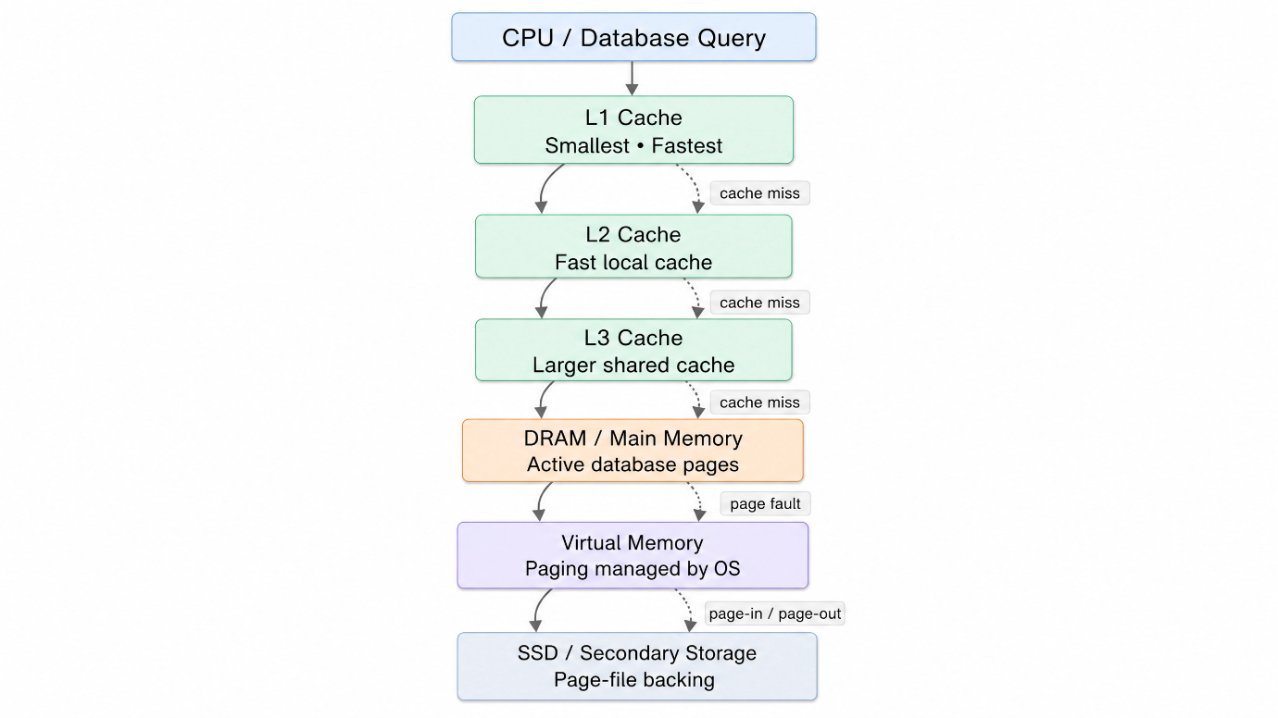
Recommended Solution
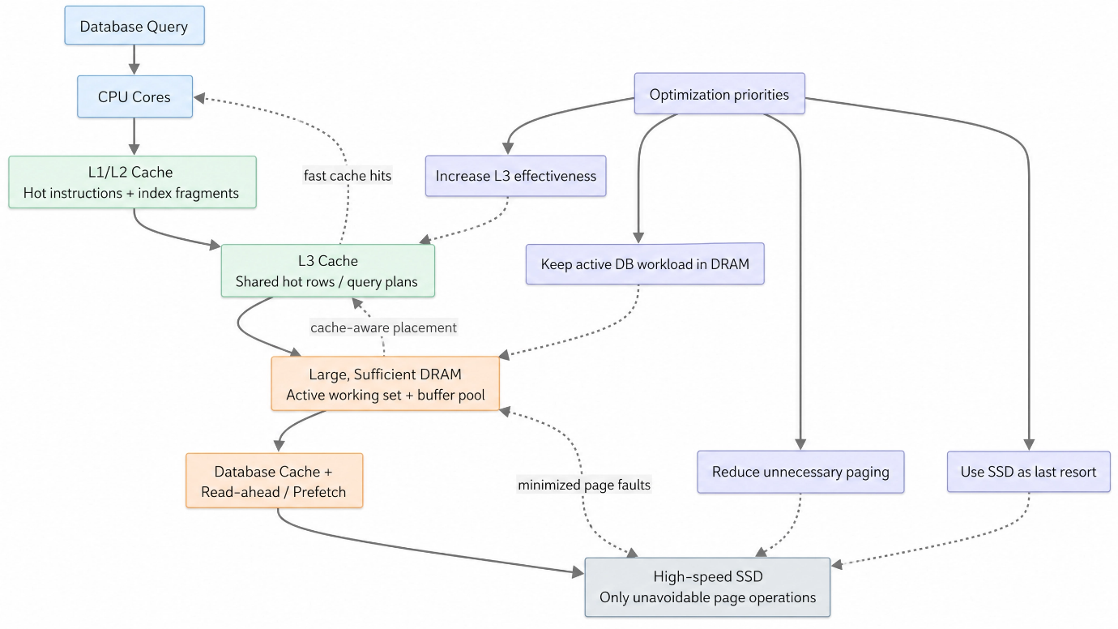

The server should use an effective cache hierarchy and sufficient DRAM to minimize page faults.

Improvements
- Increase L3 cache effectiveness.
- Provide sufficient DRAM for active database workloads.
- Optimize database caching.
- Reduce unnecessary paging.
- Use high-speed SSD storage for unavoidable page operations.
Conclusion
Cache hierarchy should be prioritized for reducing CPU access latency, while sufficient DRAM should be provided to minimize virtual-memory page faults. This combination can reduce database-query latency and improve cloud-server throughput.
Q3. Autonomous Vehicle Data Processing
Problem
An autonomous vehicle must process sensor data in real time. The memory system must provide high bandwidth and low latency. The required technologies are SRAM, DRAM and MRAM.
Analysis
Autonomous vehicles continuously process data from cameras, radar, LiDAR and other sensors. Delays in processing can affect real-time decision making.
- SRAM: Very fast and suitable for frequently accessed sensor-processing data.
- DRAM: Provides larger capacity and is suitable for storing larger working datasets.
- MRAM: Non-volatile and provides fast access with good energy efficiency.
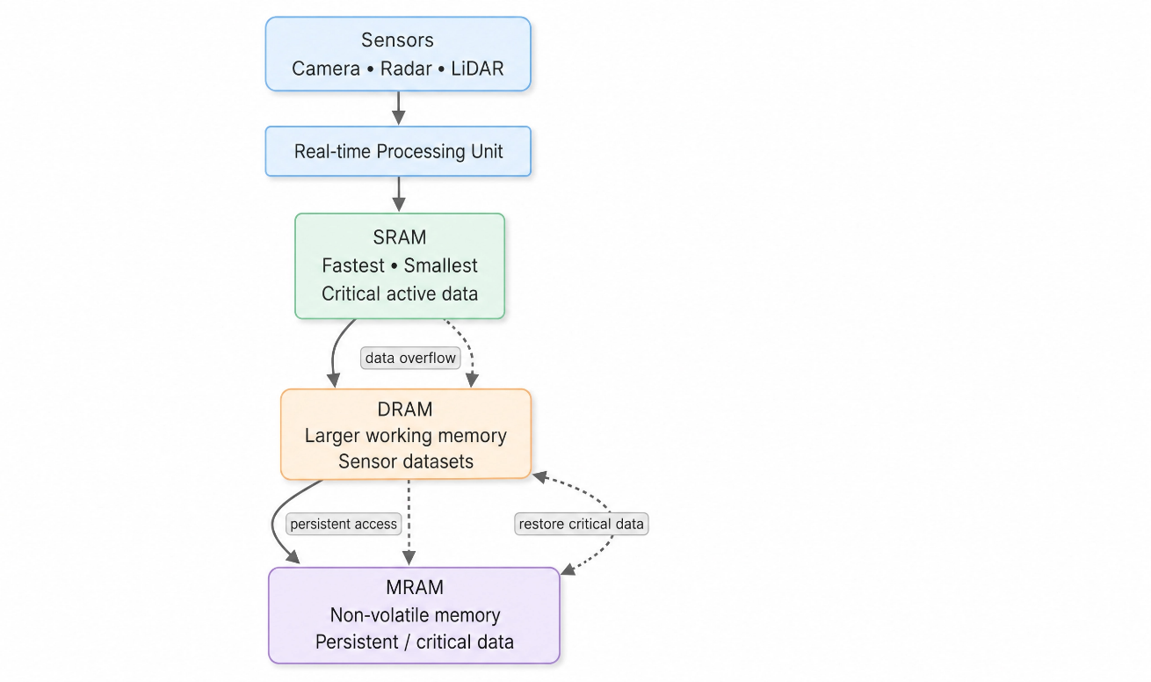
Proposed Hierarchy
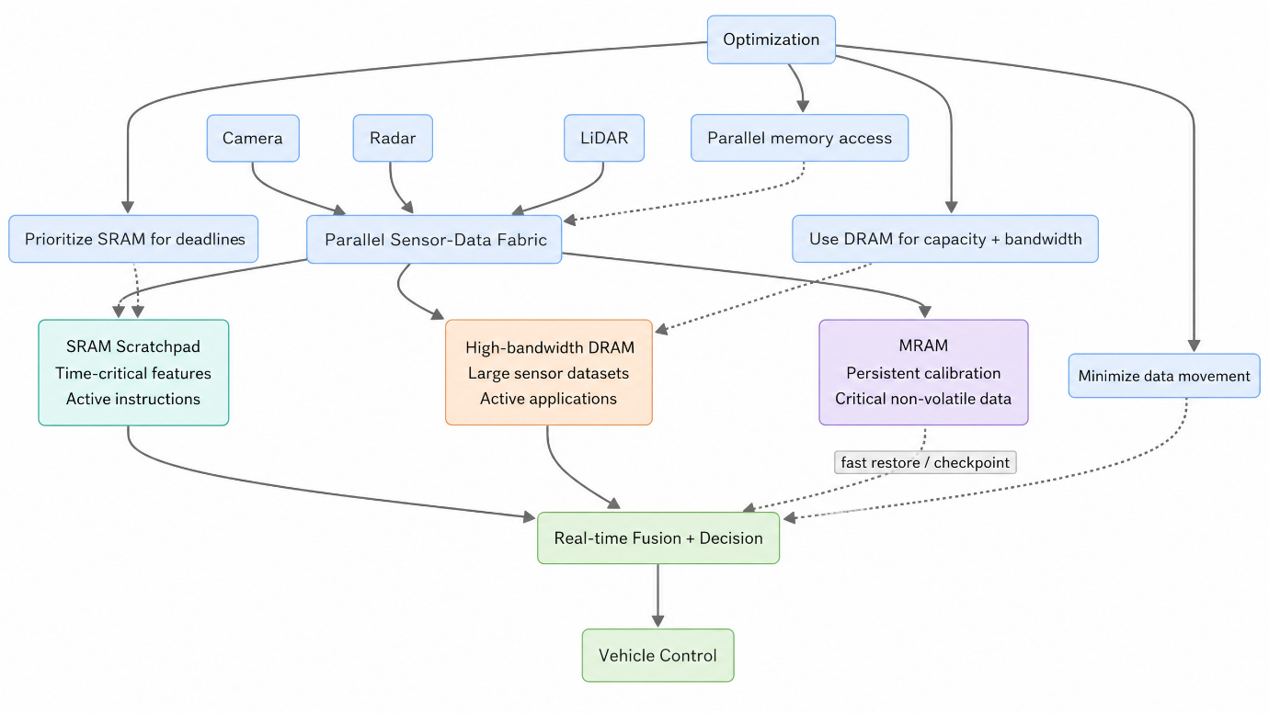
Memory Allocation
Memory | Suggested Use
SRAM | Critical real-time data and frequently accessed instructions
DRAM | Large sensor datasets and active applications
MRAM | Persistent/critical data requiring fast access

Improvements
- Store time-critical data in SRAM.
- Use high-bandwidth DRAM for large sensor datasets.
- Use MRAM for selected non-volatile data.
- Reduce unnecessary data movement between memory levels.
- Use parallel memory access where possible.
Expected Result
Frequently accessed and time-critical information can be accessed from SRAM with minimum latency, while DRAM provides the required capacity and bandwidth. MRAM provides persistent storage with fast access.
Conclusion
A combined SRAM-DRAM-MRAM hierarchy provides a balance between latency, bandwidth, capacity and energy efficiency, making it suitable for real-time autonomous vehicle data processing.
Q4. AI Inference Edge Device
Problem
An edge AI device requires fast AI-model loading while maintaining low power consumption. The required technologies are NAND Flash, DRAM and RRAM.
Analysis
AI models can be large and require fast access during inference.
- NAND Flash: Non-volatile and suitable for permanent storage of AI models.
- DRAM: Fast working memory for actively running AI models.
- RRAM: Non-volatile technology with potential for fast and energy-efficient memory operations.
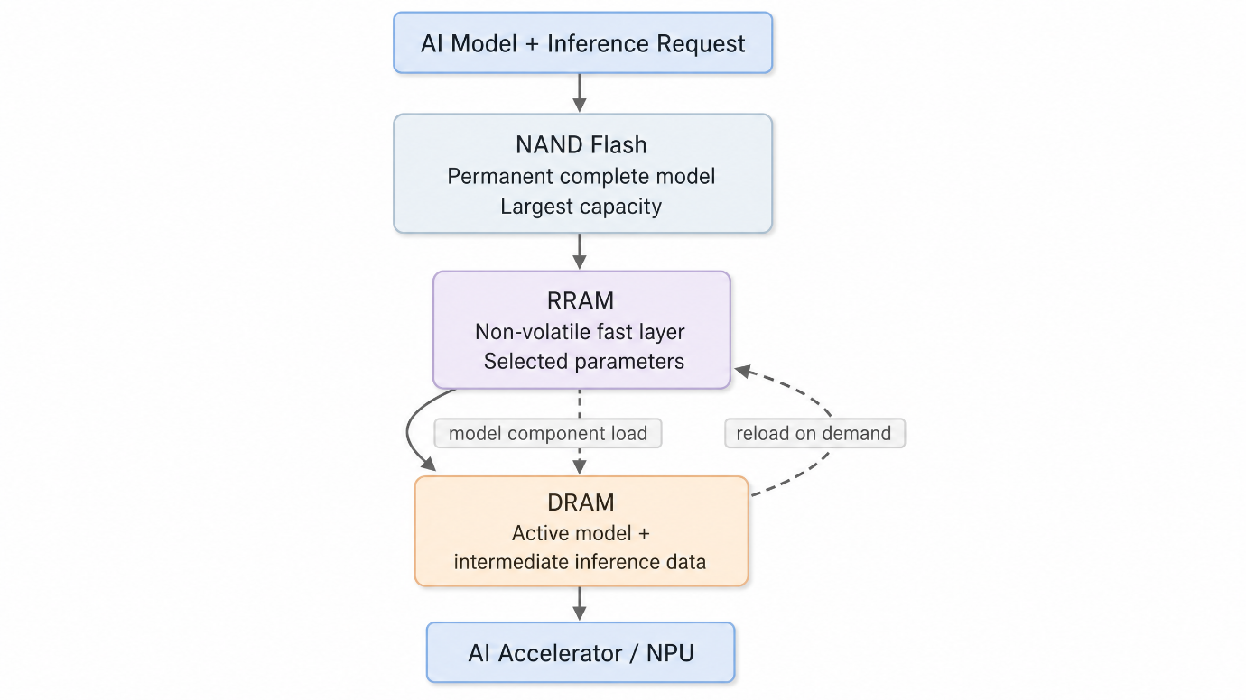
Proposed Hierarchy
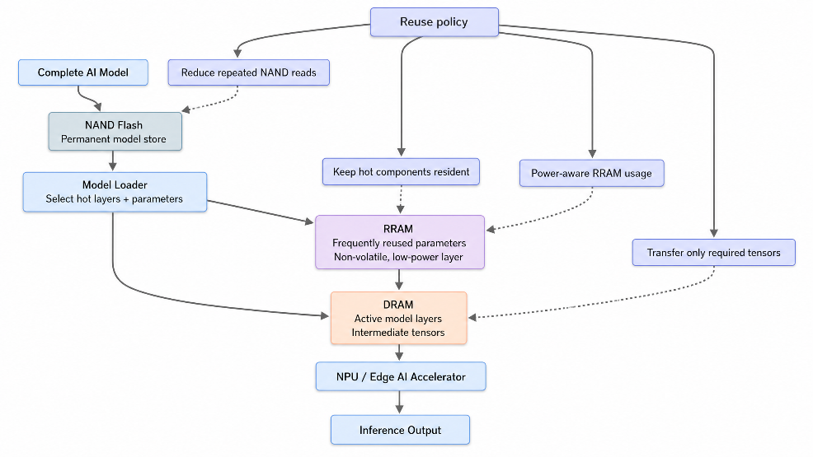
Memory Usage
NAND Flash: Stores the complete AI model permanently.
RRAM: Can store frequently used model parameters or selected data with low-power operation.
DRAM: Loads the active model and intermediate data during inference.
Improvements
- Store the complete model in NAND Flash.
- Load frequently used model components into faster memory.
- Use DRAM for active inference operations.
- Use RRAM where non-volatile, energy-efficient storage is beneficial.
- Reduce repeated loading from NAND Flash.
Expected Result
The system reduces model-loading time by keeping frequently required information in faster memory and reduces energy consumption by minimizing unnecessary data transfers.
Conclusion
A combination of NAND Flash, RRAM and DRAM provides a suitable hierarchy for edge AI devices by balancing storage capacity, access speed and power efficiency.
Q5. High-Performance Gaming Console
Problem
A gaming console experiences frame drops while loading large scenes. The problem requires analysis of L3 cache and DRAM throughput and improvements to the memory hierarchy.
Analysis
Large game scenes contain textures, models, animations and other data. During scene loading, large amounts of data must be transferred between storage, DRAM, cache and the processor.
L3 Cache
L3 cache is faster than DRAM and can provide frequently accessed data to processor cores with lower latency. However, its capacity is limited compared with DRAM.

DRAM
DRAM provides much larger capacity and is suitable for storing active game assets. However, it has higher latency than cache.
Comparison
Feature | L3 Cache | DRAM
Latency | Lower | Higher
Capacity | Smaller | Larger
Speed | Faster | Slower
Purpose | Frequently accessed data | Large working datasets
Processor proximity | Very close | Further from CPU
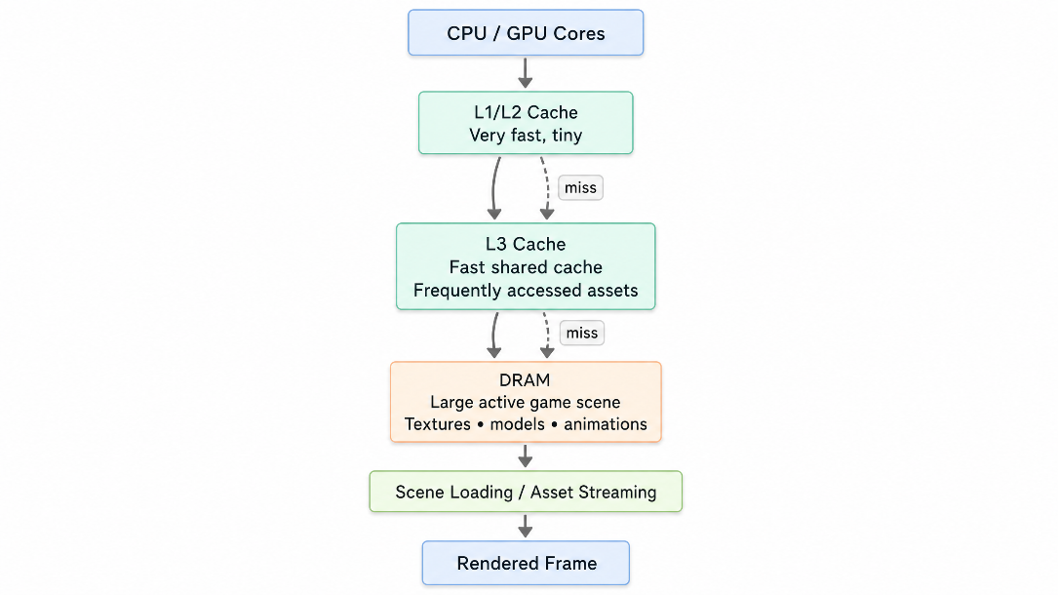
Proposed Hierarchy
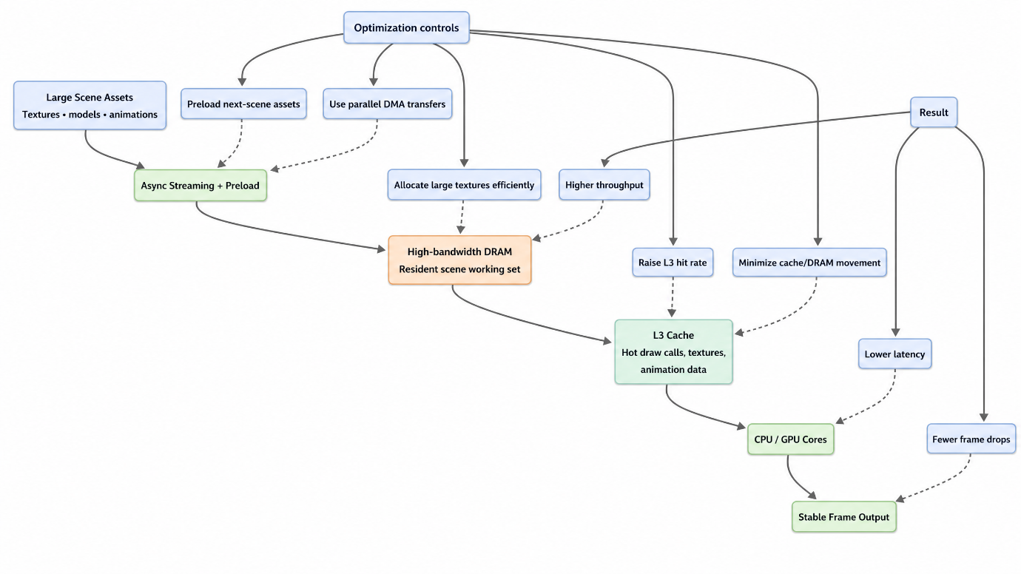
Improvements
- Improve L3 cache hit rate.
- Use high-bandwidth DRAM.
- Preload frequently required game assets.
- Reduce unnecessary movement of data between memory levels.
- Use efficient memory allocation for large textures and game objects.
- Use parallel data transfers where possible.
Expected Result
Frequently accessed game data can be supplied quickly from cache, while high-bandwidth DRAM handles large scene data. This reduces memory bottlenecks and helps maintain stable frame rates.
Conclusion
Combining an efficient L3 cache with high-bandwidth DRAM can reduce scene-loading delays and minimize frame drops. A well-designed memory hierarchy improves both latency and throughput for gaming workloads.
These solutions directly address the CO4 requirement of designing hierarchical memory systems using L1, L2, L3, DRAM, SRAM, NAND Flash, MRAM and RRAM based on latency, bandwidth and throughput.

